# Progress and Planning

Since this project has a lot of different components to be successful an effective and detailed plan was crucial to be successful. The primary method for organising this project has been using a GANTT chart and conducting team progress reviews every 3 weeks.

One of the things that had to be avoided when organising the schedule for this project is creating all of the instruments and the conductors in a serial manner, i.e. finish one and then create the next. The total allocated time to the project is 17 weeks (85 days, not including weekends) so it crucial to have the instruments being built in parallel to one another. This also ensures that if there is a delay in one of the instruments (i.e. some components are taking longer than expected to be delivered) then progress can be made on a different instrument, ensuring that team members are not being underutilised.

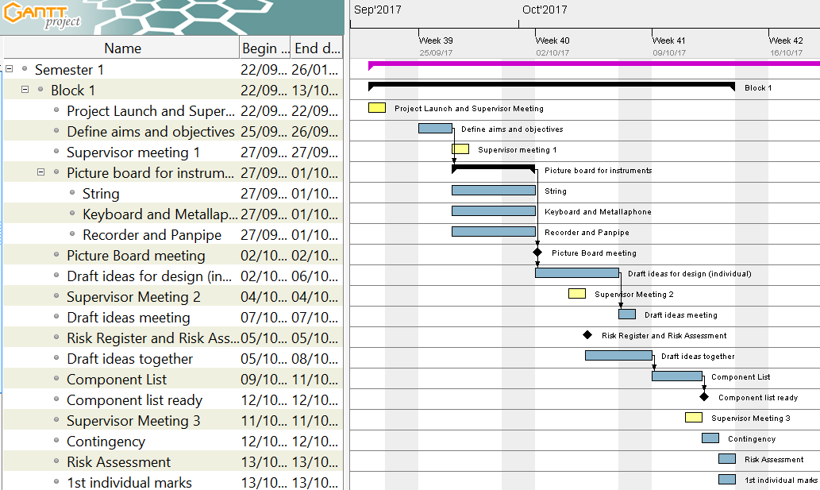

Figure 1 Initial version of the GANTT chart for Project Block 1

Figure 1 shows the initial plan for Project Block 1. The initial stages of the project were open ended so one of the first tasks was to define the aims and objectives of the project, this was followed by defining the different categories of instrument to be attempted during this project which helped in narrowing down the criteria for the research period. The research period started on the 27/09/17 through to 01/10/17 (5 days) and culminated in a picture board meeting, which helped in defining the initial four robot instruments that were going to be built: guitar, panpipes, keyboard and xylophone with two backup instruments in the Tesla coil and stepper motors. Deciding on the instruments to be made was a significant step in the project because it now meant more definitive milestones could be set and a more detailed plan could be created to ensure to progress. A milestone was created for the end of the first project block which was to have a *component list ready* (Figure 1). This meant that all necessary electronic components and hardware for the first prototypes of the instruments could be ordered to be worked on in the second project block.

Initially, this was going to be the only goal for the end of the first project block. However, specifically after *Supervisor Meeting 2*, it was realised that the instrument designs that were a product of the picture board meeting required many individual steps to be achieved and that starting with simpler designs would be beneficial to the project, these designs could then be adapted to include the additional features from the initial designs. In addition to this, having simpler designs made the *Construct the 4 instruments* (Section 2.2.2) objective more achievable. The robot guitar was also dropped in favour of a significantly simpler stepper motor design, primarily because the initial designs produced were too complex to be completed within the given timeframe. The panpipe design is currently under debate as to whether it will be progressed, it may be replaced with the Tesla coil. This will be determined after the testing period with the panpipes is over and the feasibility of the robot within the given time frame can be better understood.

In addition to this, one of the objectives was to *Select 2 suitable songs […]* (Section 2.2.2). It was realised that designing the hardware without thought towards the songs that they are being designed to play will make the designs more complicated. Deciding on the songs in this early stage ensures that the designs can be made as simple as possible.

Several new tasks and milestones were added to tackle the issues that were highlighted during the second supervisor meeting, these can be seen in Figure 3 (Appendix 2.1). It was decided that the second week should end with both the songs and hardware choices being made meaning that the hardware could be designed with specific song choices (and therefore notes) in mind. This made the design for some of the robots simpler, for example the keyboard was designed to only play 19 different notes instead of the 61 it was capable of. To decide on the song choices a Facebook poll was created where individual team members could vote on different choices, since there are only six members it was easy to get the votes from each member and the poll only had to be live for a day. The advantage of using a Facebook poll for this is that it allows individual members to add their own suggestions as well as easily tracking the number of votes each song achieves. The next day a meeting was held to discuss the most voted song choices and integrate them with the MIDI files of the songs using Anvil Studio. In order to make sure that the *Component list ready* milestone could still be completed on time the songs and instruments needed to be selected by the end of the second week. This is because, in order to create a component list, 3D models were needed which could take a significant amount of time to develop. The milestone for the first project block was achieved and a component list was constructed and ordered which gave 3 weeks for the components to arrive, ready to be used at the start of the next project block.

During the first module block the priorities for the group switched from making significant progress on the project to focusing on individual modules. The work done on the project during this time focused mostly on preparing for the upcoming tasks of the second project block and preparing for the first significant project deadline – *Interim Report.* It was clear that in order to achieve this milestone a significant amount of work would need to be executed. So, in order to pre-empt the workload, and ensure that no time was wasted planning during the second project block, several meetings were held where the approach to achieving the deadline for the interim report was discussed. The first meeting (*Interim Report Meeting – Contents Page)* was used to create a contents page for the report which was used in the next meeting (*Designate Interim Report Roles*) to designate individual sections to individual team members. There was another meeting (*Interim Meeting 3)* which took place two days before the start of the second block. This was deliberately close to the start as it was used to discuss the plan and milestones for the second project block.

The second project block was more complex to schedule because there were more milestones and they often required the same people working on them. The milestones for the end of the second project block were:

* Software for stepper motors created
* Keyboard software simulation created
* Construct the hardware for the xylophone
* Keyboard hardware submitted for manufacture
* Submit the First Interim Report

To make sure that these milestones were achieved several of the tasks were run in parallel. Also, in project block two the team was split in to a hardware team (four members) and software team (2 members). The slight bias towards the hardware team is due to the higher amount of work to be completed on the design and construction of the robot instruments. The reason for choosing the stepper motor software to be created first is because of the low hardware requirements that the stepper motors had, the circuits were quite simple and one could be connected to the Arduino with relative ease. The software development could start from early on in the project block.

Fortunately all of the components that were ordered in the first project block arrived on time so the drive boards and power supply necessary for the steppers to operate were ready to be used by the software team. Several of the components had been delivered for the keyboard and xylophone so a testing phase began. Each of the testing phases was started with a goal in mind. For example, the *Solenoid Testing for Keyboard* task (Appendix 2.1) was created to check whether the solenoids that had been ordered in the first project block were strong enough to push down the keys, if they were not then completing this phase would ensure there was enough time to order more in and still make progress on the keyboard hardware.

Highlighted in blue in Figure 2 is the approach towards the interim report. A draft of the report was to be made ready by the start of the last week of the block, 20/11/17 (a week before the deadline). This ensured that there was enough time to conduct a table read and perform any edits. It was debated whether a week may be too long and that the time may be better spent working on the technical progress of the project and having more time to write the report, pushing the deadline for the draft to Wednesday (22/11/17). Due to the size of the report and the amount of time it would take to conduct a table read the initial date was settled on and remained as the deadline for the first draft. This approach worked well, the interim report was submitted on time and there was ample time to edit the document and have it ready. Spacing the editing out over the course of a week resulted in the team still being able to meet the deadlines for modules outside of the project.

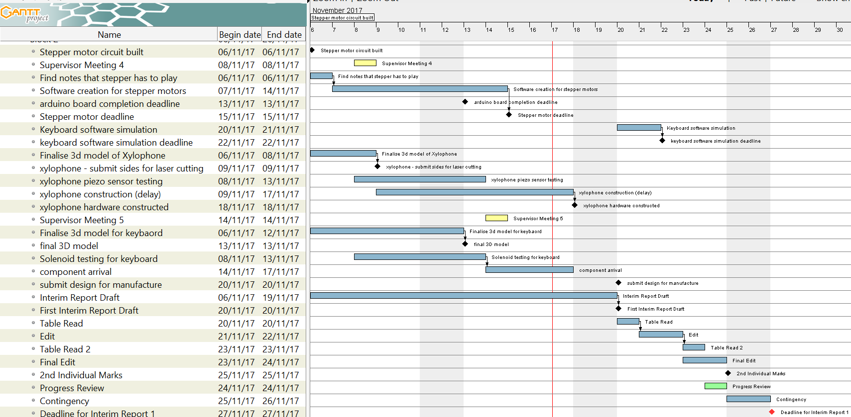

Figure 2 GANTT chart for Second Project Block

However, one of the *Keyboard software simulation* milestone (due for 20/11/17) was not completed on time. This was partially due to the interim report taking priority over other workload during the last week and due to the size of the sub teams. In order to address the latter, in the second semester the software and hardware team will contain three members each. This will provide more resources to the software team so that two instruments can be worked on at the same time, instead of one at a time.

## Approach towards 2nd Semester

As discussed previously, both the hardware and software teams will be evened out in the second semester which should help to achieve both the hardware and software goals in the upcoming project blocks. Below is a summary of the remaining tasks for each of the instruments. The GANTT charts for the blocks in semester 2 can be seen in **Appendix section.**

**Keyboard:** The software simulation for the keyboard will take significant amount of time to complete so will form the main part of the third project block. It is worth spending a significant amount of time on this section because both the Xylophone and Keyboard will use very similar software – so building the keyboard software with this in mind will reduce the amount of time spent on the Xylophone. The Keyboard simulation software will start development at the beginning of the second week of project block 3. It is currently scheduled to be completed by 12/02/18 (week three of the third project block). By this time the hardware for the keyboard will also be constructed so the remainder of the block will be spent on integrating the software simulation with the hardware.

**Xylophone:** The hardware for the Xylophone has now been delivered and constructed. The next stage would be to write the software and integrate it with the hardware. As mentioned in Section 4.4 the hardware was given a new design which was significantly simpler than the previous design. This also has the added benefit of the software between the Xylophone and Keyboard now being very similar in structure. Because of this, finalising the Xylophone should not be a very long task once the Keyboard instrument is completed. Adapting the software of the Keyboard to suit the needs of the Xylophone hardware will take place at the start of the fourth project block.

**Panpipes and Tesla Coil:** The plug for the air pump used on the panpipe was delayed by a week which has delayed the testing to the start of the next project block. The Tesla Coil currently looks like it would make a good addition to the orchestra, however more research needs to be conducted in order to determine how the Tesla Coil will be scaled up. In, **Reference to project block 3 gantt chart in appendix,** there are tasks to perform some preliminary tests on the panpipes with the air pump and do some research on scaling the Tesla Coil up to operate at a higher voltage. These are scheduled to be completed partway through the second week of the third project block (07/02/18), by the end of the third project a block a decision will be made whether to move forward with the Tesla coil or the robot panpipes.

**Stepper Motors:** The current software iteration of the software allows for one stepper motor to be controlled and play a song. However, the initial design involved having four stepper motors synchronised with each other. This is now being explored by researching various timers. Before the start of the third project block a decision will be made on what method will be best suited for achieving multiple stepper motors at once. The beginning of the third project block (30/01/18 – 06/02/18) has been dedicated towards achieving the *Multiple Stepper Motor Software Deadline* (06/02/18). It was found that the noise from the steppers was amplified when fixed on to a wood surface. To capitalise on this, a wooden speaker box will be designed in the first week of the third project block and be fixed to the stepper in the third week. The entire stepper motor instrument has a completion date of 14/02/18 (third week of project block three).

**Conductor Design:** The main task to be completed with the conductor is to decide the method of communication between the Raspberry Pi and the four robot instruments. A deadline has been set for the end of the third project block (15/02/18) to make this decision. Once this has been a step-by-step will be created to create the conductor by the end of the fourth project block. By the end of the first week in the fourth project block the hardware for the instruments should be complete, this means that more resources can be applied to designing and constructing the conductor.

## Risk Management

In order to identify the potential risks that project faces a risk register was established, which allowed some mitigations to be put in place. The full risk register can be seen in **Appendix 1.1.**

Risks 1, 5 and 9 are not from direct action of the team and have to be mitigated. One of the ways in doing this is to add contingency time at the end of each block. From Figure 2 and **Error! Reference source not found.** It can be seen that this was done, giving two days at the end of each block for tasks to overrun. During the second project block the testing phase for the panpipes was supposed to begin at the start of the second week, so that the feasibility of the panpipes could be determined. However, since the plug that was needed to power the air pump was delayed until the end of the second week the testing phase was delayed. The contingency time attached to the end of the second project block had to be used to compensate for the delay, giving two additional days to work on the testing for the panpipe. Risk 5 should not be much of an issue (shown by its *Probability being equated to 1*) since a locked cupboard has been provided, all built equipment shall be stored in there and the key is removed from the room.

Risk 2 has the potential to cause significant setbacks in the project, especially since the team has been split into hardware and software. However, the risk is somewhat reduced by having several members in each team and more than one person on each task. This ensures that more than one person is familiar with each task that is currently ongoing with the project so if someone was to become unavailable then another member will be able to pick up from the last member that left it. Also, the team has weekly meetings where the whole team is present (this is in addition to the supervisor meetings). The primary goal of these meetings is to check on progress made in the previous week but they also allow members to update each other on specific tasks. This means that if another member has to pick up the work of another there is only, at the maximum, a five day gap in the workload.

Risk 4 is reduced by using Google Drive. Since Google Drive is a completely online file storage system every file can be accessed by each individual member. This acts as a good back up to the local files stored on individual laptops.

Risk 7 is due to none of the team members having previously used a MyRIO (**figure from introduction regarding skills)**. In order to mitigate this risk two actions were taken. Firstly, the National Instruments Student Scholarship was applied for, where one of the benefits is being provided with a National Instruments Engineer. Then a training session was organised with a National Instruments Engineer to provide an introduction to the MyRIO and to demonstrate its capability. In order to further reduce this risk all members of the team will be present at the training session so that everyone can be assumed to be at the same level for the MyRIO after. This ensures that individual team members can provide support to others should there be problems using it.

Risk 8 is mitigated by constructing components lists before ordering a significant amount of components (such as at the end of the first project block). This gives the opportunity to review the items being ordered and ensure that they are within budget, it also gives time to look for alternatives to the products ordered. Some may be cheaper if factors such as delivery time are more flexible. For example, at the end of the first project block there was a three week period that the items could be delivered in so cheaper alternatives for the solenoids could be selected. These were exactly the same solenoids that were going to be ordered but because they had a longer delivery time the total cost per solenoid was cheaper.

Risk 10 is in regards to only one member of the team having skills in one particular element of the project. For example, only one member of the team has previous experience in using the Raspberry Pi, which means that should a person become unavailable it may be heard to keep progressing on any tasks relating to the RPi. In order to mitigate this, any task involving the RPi will involve more than one member of the team, ensuring that each member is able to use the RPi for this project.

# Appendix

|  |  |  |  |  |  |  |  |
| --- | --- | --- | --- | --- | --- | --- | --- |
| **No** | **Date** | **Risk description** | **Impact L=1, M=2, H=3** | **Probability P L=1, M=2, H=3** | **Risk rating [I x P]** | **Risk owner** | **Risk treatment (Mitigate, Accept, Transfer as appropriate with any actions and due dates)** |
| 1 | 05/10/2017 | Late Delivery of Components | 3 | 2 | 6 | A BURUINA | Transfer as appropriate with any actions and due dates |
| 2 | 05/10/2017 | Team member unavailable for various reasons | 3 | 1 | 3 | J CHANDA | Accept |
| 3 | 05/10/2107 | Design is taking longer than expected to finish | 3 | 2 | 6 | J CHANDA | Ensure that designs are simple in the initial design stage |
| 4 | 05/10/2017 | Loss of electronic files | 3 | 1 | 3 | A PETROVS | Ensure files are backed up both online and locally. Local backup should be disconnected from main file source. Each member to retain individual backup of files. |
| 5 | 05/10/2017 | Equipment being stolen | 3 | 1 | 3 | TEAM | Make sure equipment is secured in D1 after use and stored away out of site. |
| 6 | 05/10/2017 | Damage of equipment | 3 | 1 | 3 | TEAM | Make sure the equipment is stored correctly when being transported. |
| 7 | 05/10/2017 | Unfamiliarity with myRio | 2 | 1 | 2 | F FUMAGALLI | Meeting arranged with NI technician |
| 8 | 05/10/2017 | Using up the budget | 2 | 1 | 2 | A BURUNIA | Have an itemised list of all components being ordered. Ensure the total amount is less than the budget allowance. |
| 9 | 05/10/2017 | Faulty equipment delivered | 2 | 1 | 2 | A BURUNIA | Accept |
| 10 | 21/11/2017 | Only one person having experience with Raspberry Pi - single point of failure | 2 | 1 | 2 | J CHANDA | Ensure multiple people are working on tasks related to the Raspberry Pi. |

Table 1 Risk Register

# New GANTT chart – including song choices meeting and hardware redesign

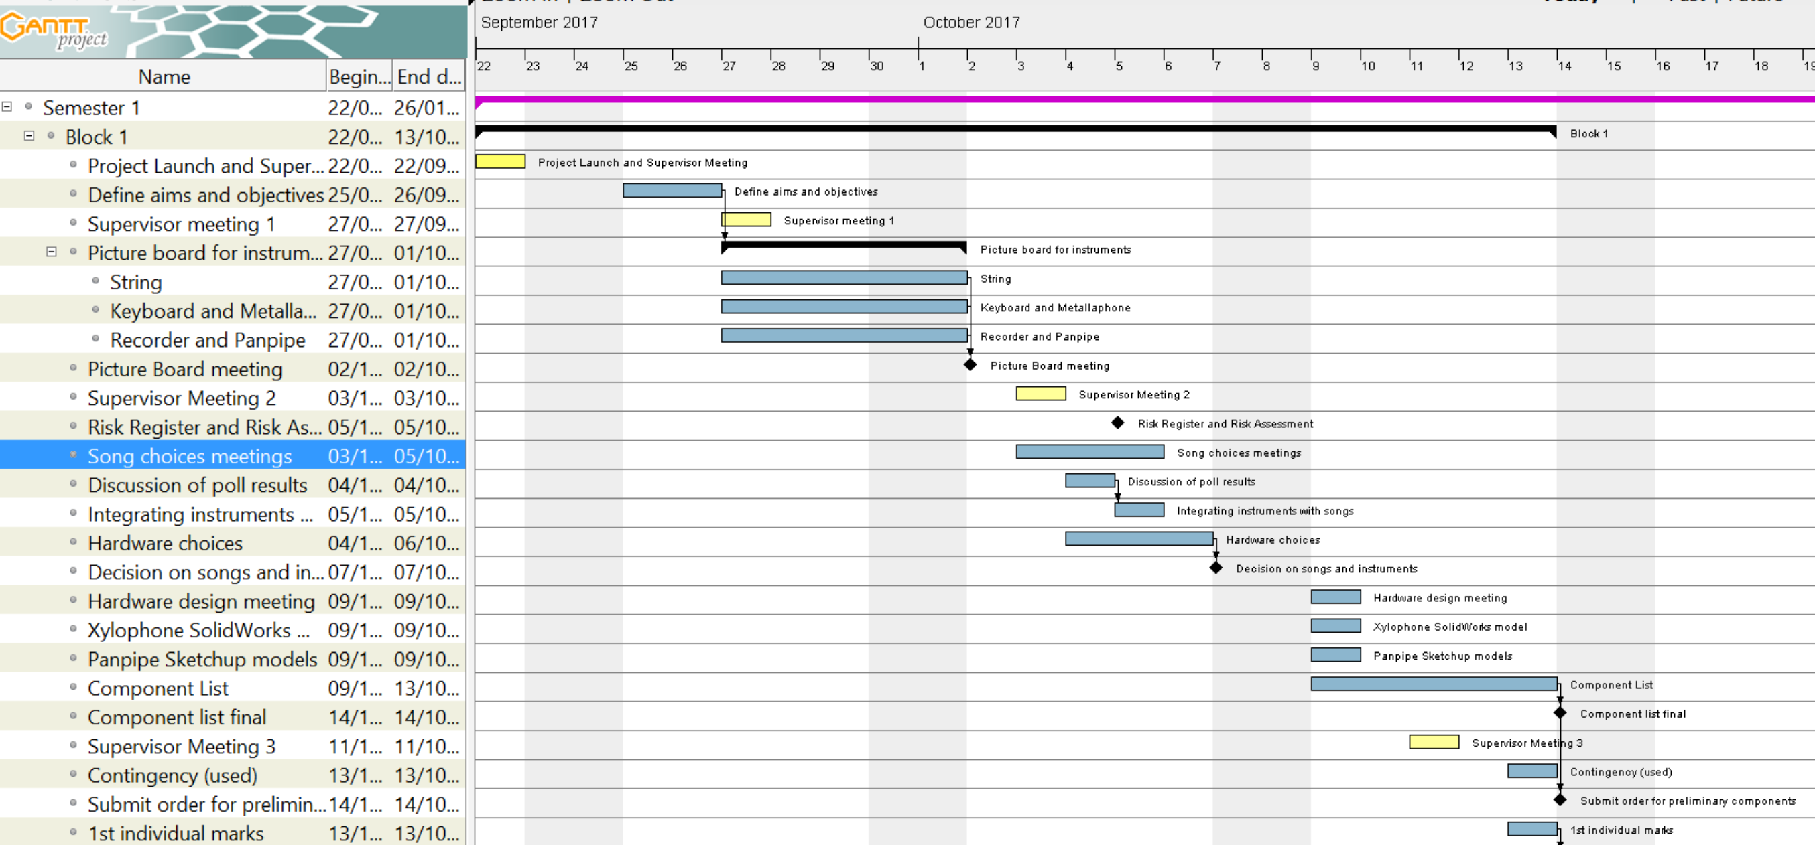

Figure 3 GANTT chart including song choices meeting and hardware redesign

# Project Block 3

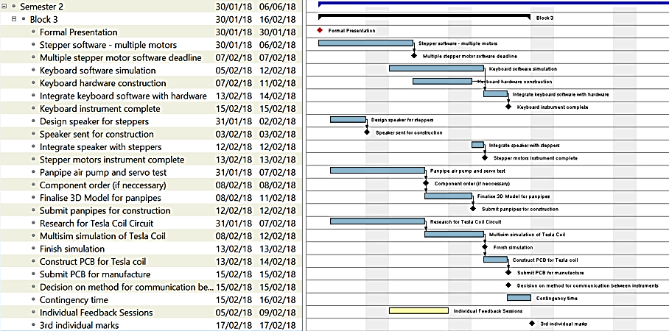

Figure 4 Project Block 3

# Project Block 4

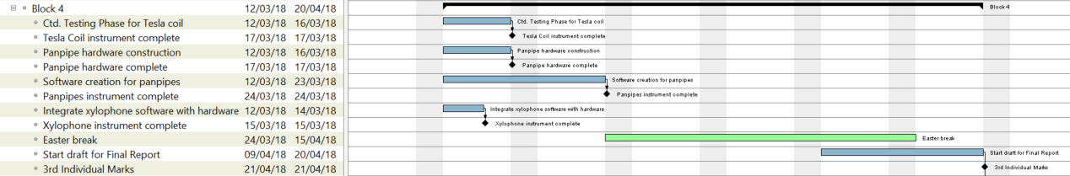

Figure 5 Project Block 4

# Project Block 5

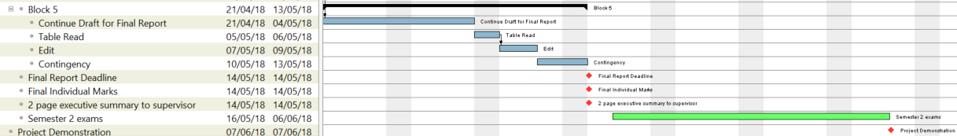

Figure 6 Project Block 5